Budgetwise
Week 8 | 2026-04-04 - 2026-04-10

Leader: Jonathan Strong

Jonathan Gruber  Time Spent  15 hours | Tasks completed:  - Update architecture diagram  - Testing forgot/reset password functionality  - Test Docker deployment  Planned tasks for next week:  - Work on any remaining back-end functionality for which I have sufficient knowledge  - Maintain architecture diagram  Any issues or challenges:  - (Resolved) merge conflicts between Docker branch and personal work branch in Git repository  - (Resolved) Typescript type errors when running Docker
Casandra Marquez  Time Spent  14 hours | Tasks completed:  - Fixed Docker local issues with current front_back_merge branch  - Set up free Render services running Docker setup  - Successfully deployed frontend, backend, and database services  - 3 separate links  - Started putting frontend and backend together in Render  - Fixed issues connecting backend URL to frontend  - https://cs4485-alagar-team1-1.onrender.com/  Planned tasks for next week:  - Update docker-setup branch after debugging forked repo  - Figure out frontend port changes  - Add permissions to GitHub to deploy  Any issues or challenges:  - Render setup  - Issues deploying frontend and backend
Haru  Kimura  Time Spent  9 hours | Tasks completed:  - Continued implementation of forgot/reset password functionality from last week  - Integrated reset password frontend with backend API  - Improved error handling to properly display backend validation messages on the reset page  - Fixed issue where the page reloaded on invalid or expired reset links; now stays on the page and shows appropriate error messages  - Refined user-facing error messages for better clarity (e.g., invalid or expired link)  - Configured SMTP email service for sending reset password links  - Tested full forgot/reset password flow end-to-end  Planned tasks for next week:  - Continue frontend-backend integration for remaining features  - Assist with merging branches and resolving integration issues  - Support testing and debugging across the application  - Improve UI/UX for authentication-related components if needed  Any issues or challenges:  - Initial issues with environment variable configuration for SMTP  - Prisma database not initialized, causing missing table errors  - Debugging frontend-backend connection for reset password functionality  - All issues were resolved, and full functionality was verified
Marcelo Mejia  Time Spent  8 hours | Tasks completed:  - Added the mock data import command that was part of the previous database implementation to this one. Instructions for how to run are in github budgetwise readme.  - Now that docker deployment has been set up, I focused on more quality of life/ease of use features for a more industry standard feel.  - Some visual/UI features added, including the ability to switch from a light/dark mode, and change the color of your avatar. Both of these can be accessed in settings  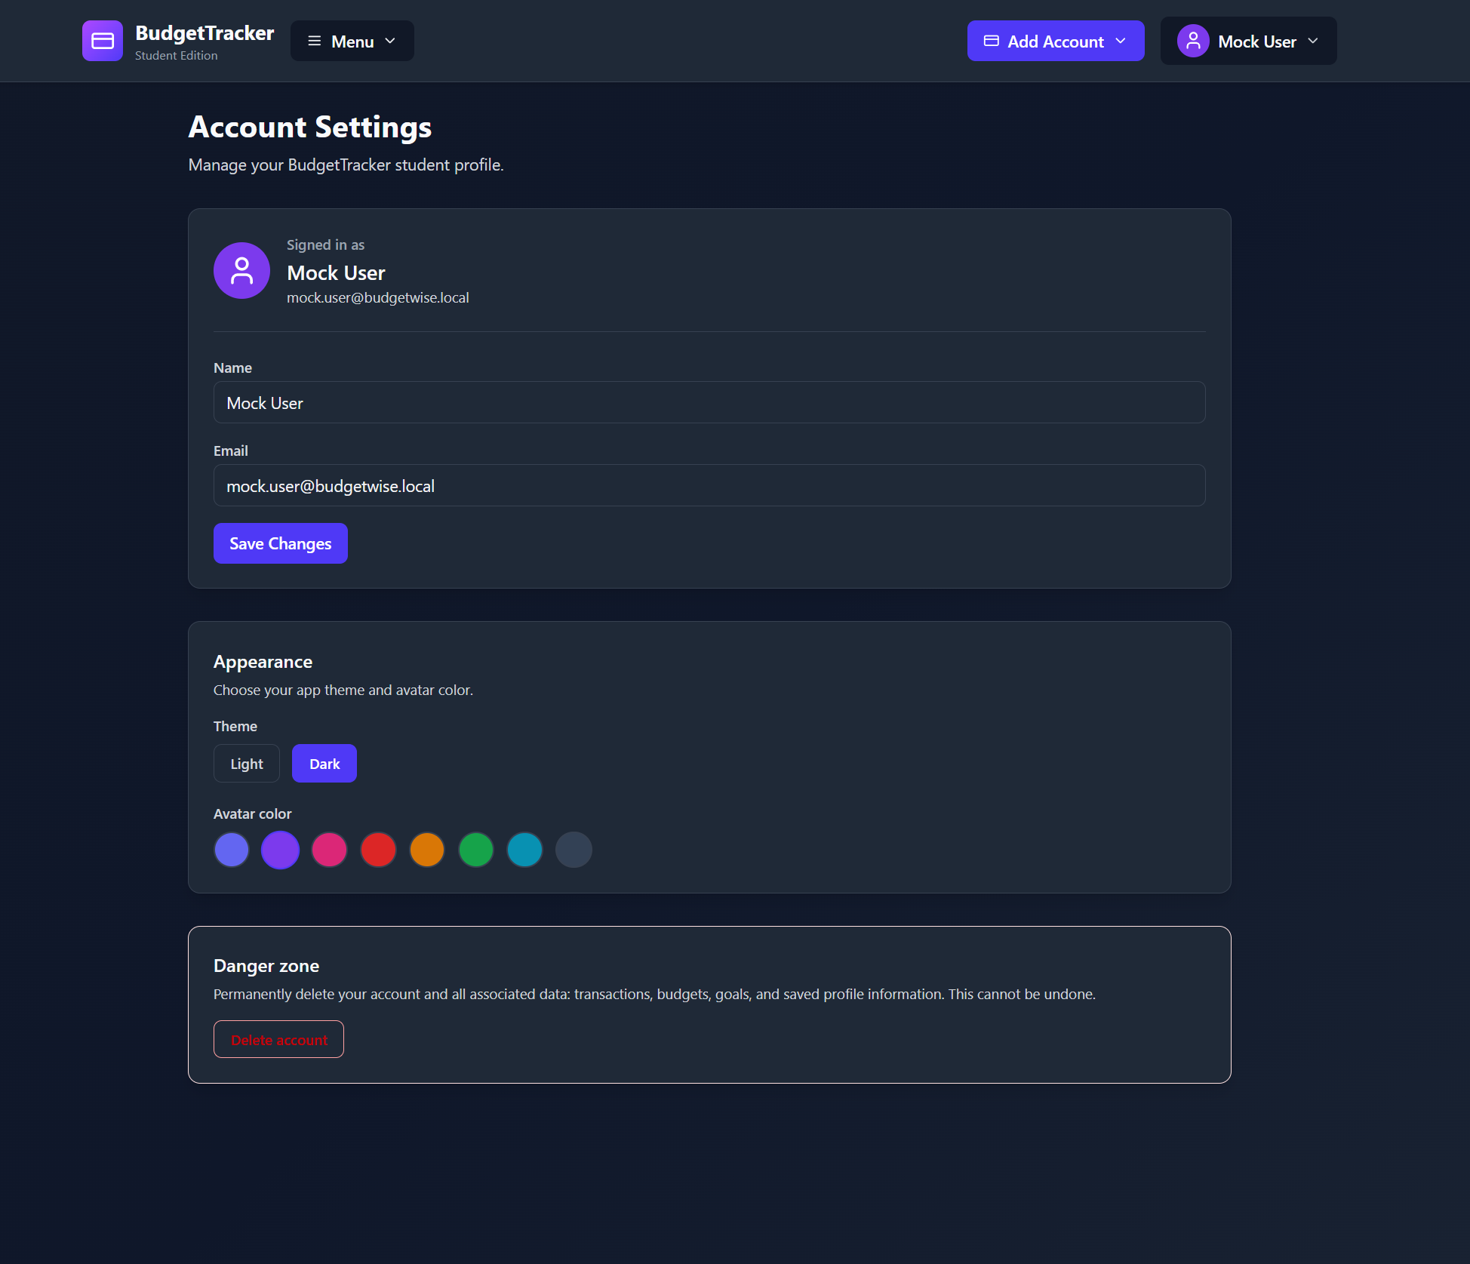  - New graphics in the dashboard show the user's most recent transactions, with a button that takes the user to the transactions page if they want a more in-depth view.  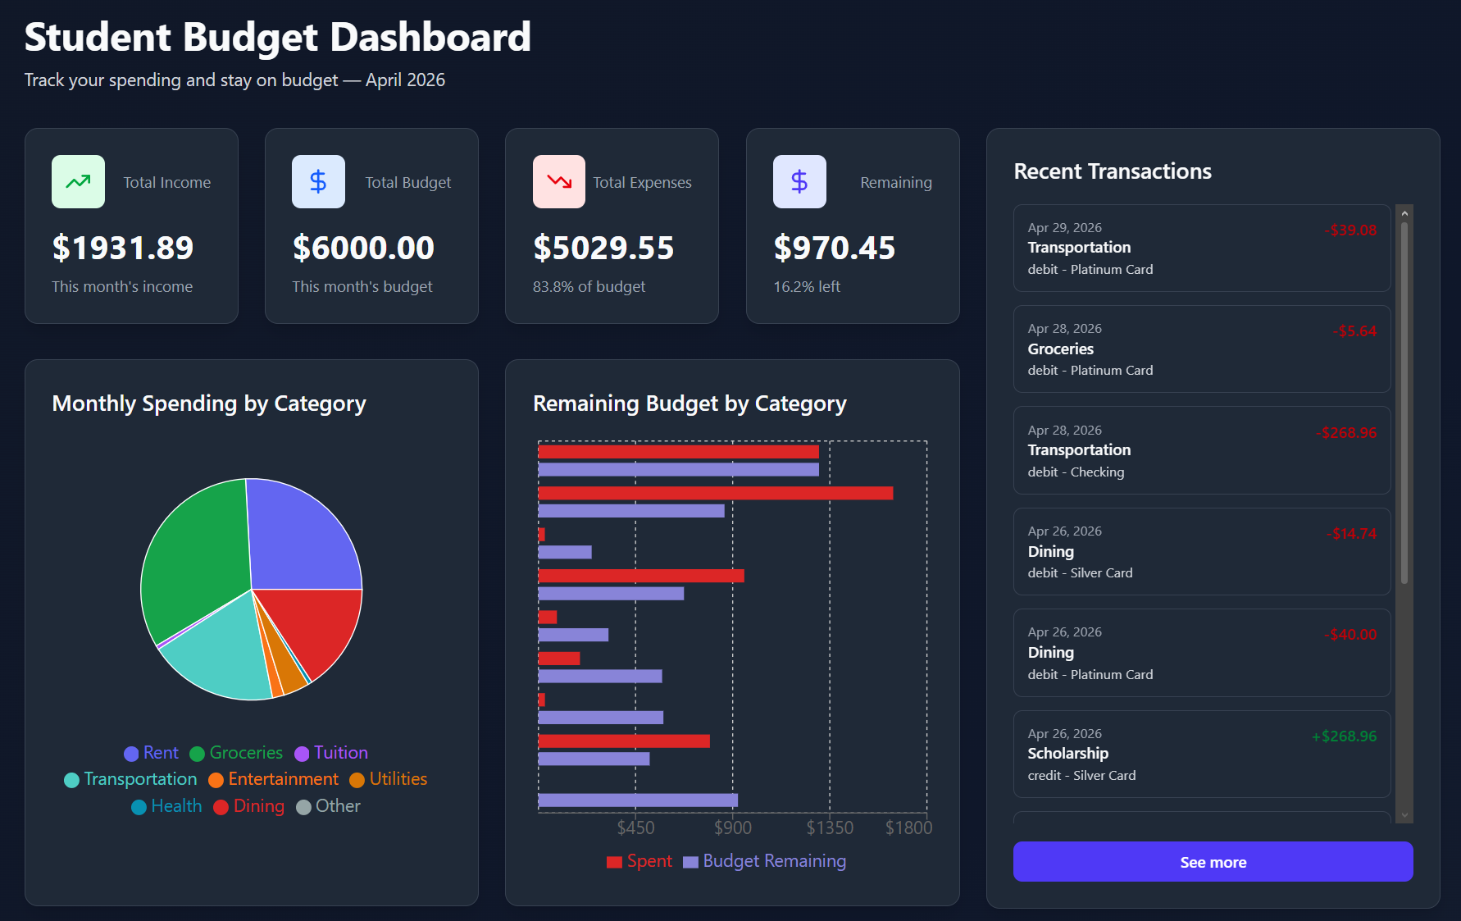  - The AI budget creator was suggesting a static percentage value to allocate to each spending category. Now it makes use of the AI API to suggest percentages based off of the data in the transactions page:  - Categories that jump around alot in spending will be averaged based on previous months to be used as a sort of baseline suggestion.  - For categories that are pretty consistent in spending across months, the AI will opt for small cutbacks to support saving money.  - Categories with extremely consistent spending numbers (rent, for example), will be given a hard ceiling in the budget.  - AI will warn the user if they do not have a lot of data yet ( be prepared for skewed results), or no data at all (user will be given default budget values)  - Of course these are all just suggestions, which is why the ability for the user to change the budget as they see fit is still available.  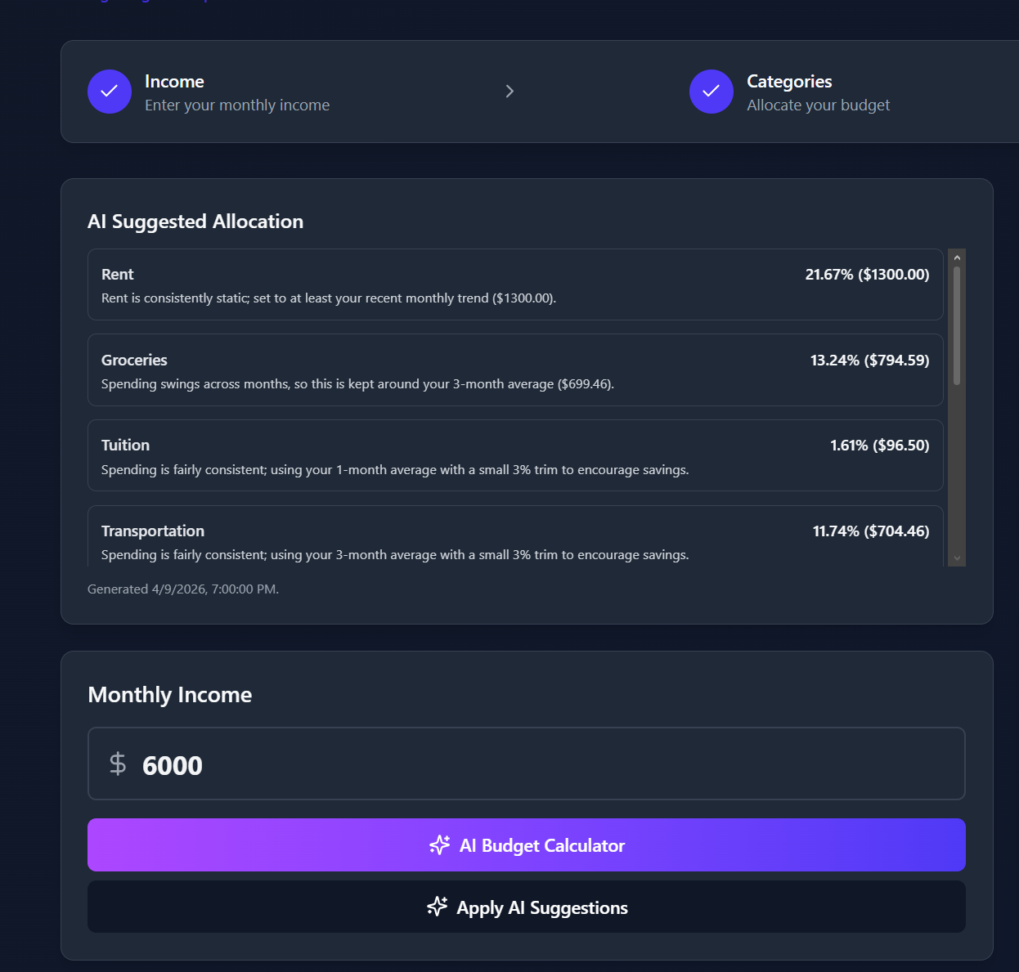  Planned tasks for next week:  - Fix small UI issues (dark mode)  - Continue with fine tuning AI features and making the app look nicer.  - Help with scalability if needed  Any issues or challenges:  - Exam + slight issues with docker setup (fixed eventually)
Jonathan Strong  Time Spent  6 hours | Tasks completed:  - Set up docker on my machine  - Pulled latest docker-setup versions  - Scalability Testing  - Added a new load test folder with a read me that explains how to run the stress tests on the docker deployed version  - Made a new doc for findings  - Summary  - On docker it was able to safely have 25 users doing read only requests for 2 minutes  - Tried to simulate 300 users worth of read and write requests but became quickly taxing on my machine so stopped early  Planned tasks for next week:  - Figure out how to optimize it to safely allow many users to read and write at the same time  Any issues or challenges:  - Had to replace computer so was unable to work until Thursday
Sophia Chau  Time Spent  6 hours | Tasks completed:  - First iteration of the bank feature using Plaid  - Only Plaid Sandbox, full integration requires payment (no other free alternatives I could find)  - Do not merge this branch, I need to do fixing and likely some overhaul  - Spoke with Plaid representatives  Planned tasks for next week:  - Improve scalability document  - Continue work on Plaid integration  Any issues or challenges:  - Had all of my exams this week, was not able to dedicate time to this project  - Personal issues continue (this is not going to get better)

Total Time Spent: 58 hours

Summary:

